# Project Design Phase-ISolutionArchitecture

|  |  |
| --- | --- |
| Date | 15.10.2022 |
| Team ID | PNT2022TMID09878 |
| ProjectName | DemandEst-Al powered Food Demand Forcaster |
| MaximumMarks | 4Marks |

**SolutionArchitecture:**

For a forecasting process to be robust, the first and foremost pre-requisite is to have the right data. A faulty data set could result in false predictions, which will impact an organisation’s sales and profitability. A greater emphasis should go into having the right data strategy. Amazon’s success story would not have been possible without having a data strategy in place. The data strategy should also be in line with the company’s goals. It should prioritise making the data representative of the company’s goals or what it is trying to achieve through the demand forecasts.

Second is the scale. Nowadays organizations produce massive amount of data within a very short span of time. 80-90% of this data is unstructured, 70-75% of it are unused (according to the CIO and the Forrester research respectively). The forecasts are often required at a very granular level to align with the broader organizational objectives. For an example, an industrial equipment manufacturer will be interested in forecasting demand for a special purpose pump for a certain area to determine the raw material demand in the nearby plant. The manufacturer may sell thousands of products across and beyond the country that will require 100,000 plus ML models to run to generate the end outcome. This calls for massive computing power and ability to parallel processing. The advancement of cloud technologies combined with big data services, helps the organizations to solve for scalability element.

* Hardware Required for the Project are :

There are two primary processors used as part of most AI/ML tasks: central processing units (CPUs) and graphics processing units (GPUs). CPUs are suitable to train most traditional machine learning models and are designed to execute complex calculations sequentially.

AI architects envision, build, deploy and operationalize an end-to-end machine learning (ML) and AI pipeline. AI architects can help build a robust enterprisewide architecture for AI and collaborate with data scientists, data engineers, developers, operations and security.1

.

# Example -SolutionArchitectureDiagram:

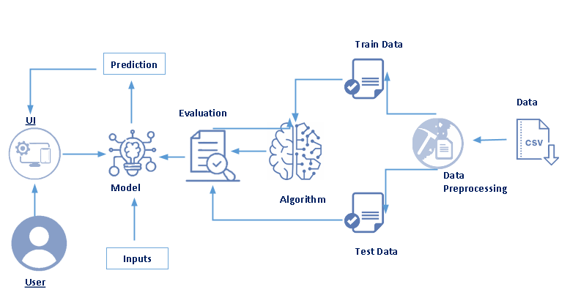

IoT Device